**Ideation Phase**

**Brainstorm & Idea Prioritization**

|  |  |
| --- | --- |
| Date | 25 June 2025 |
| Team ID | LTVIP2025TMID30212 |
| Project Name | SmartSDLC – ai-enhanced software development lifecycle |
| Maximum Marks | 4 Marks |

**SmartSDLC – ai-enhanced software development lifecycle:**

This project addresses the challenge faced by software developers in comprehending and maintaining large or unfamiliar codebases. The primary objective is to build an AI-powered assistant that leverages IBM WatsonX's Granite large language models to provide intelligent code summarization, logic explanation, and documentation support. By integrating this functionality into an interactive web-based platform, the system aims to enhance developer productivity, accelerate onboarding processes, and reduce the cognitive effort associated with code understanding and maintenance.

**Step-1: Team Gathering, Collaboration and Select the Problem Statement**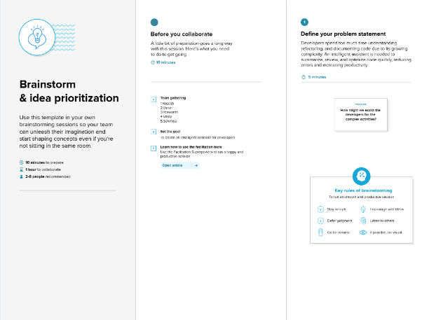

**Step-2: Brainstorm, Idea Listing and Grouping**

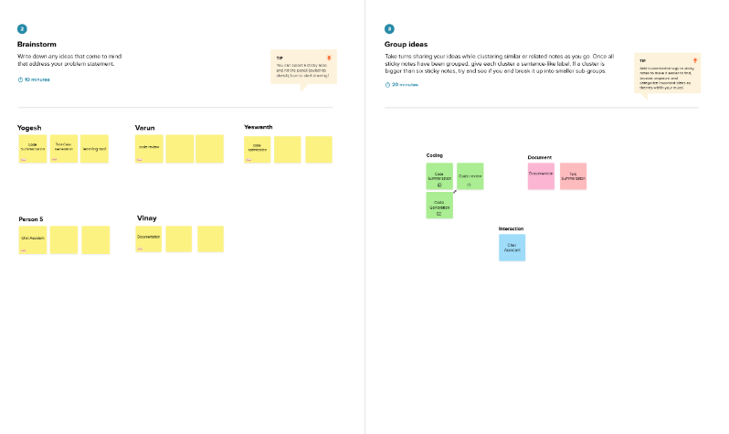

**Step-3: Idea Prioritization**

